
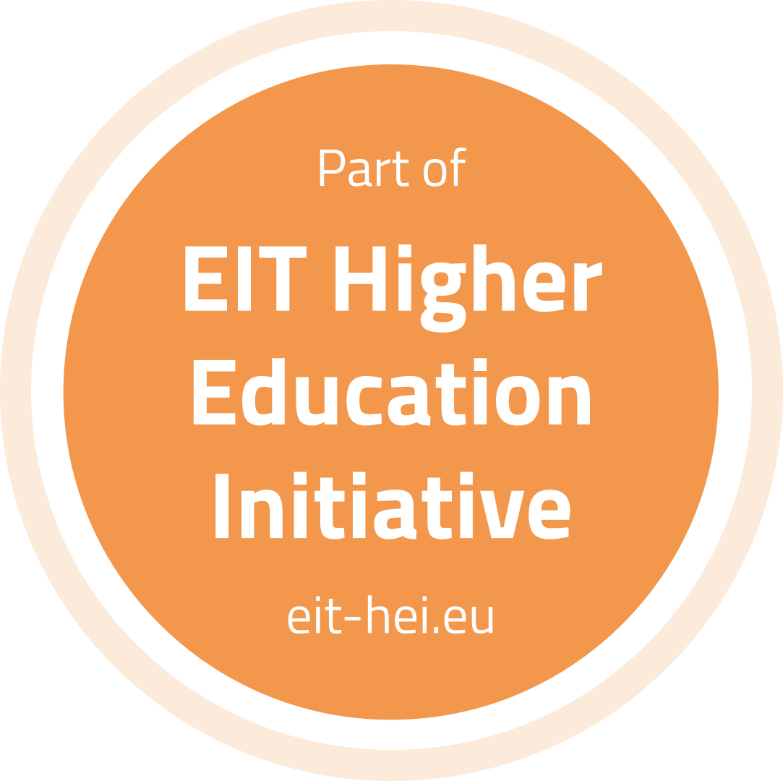
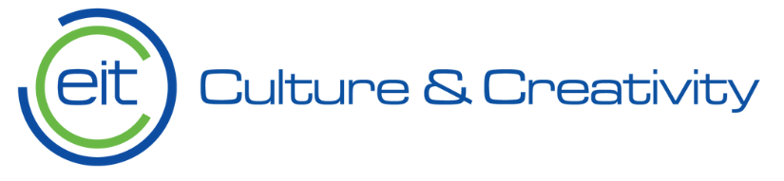


Vabljeni:
• Udeleženci programov usposabljanja projekta CreaTech na EMUNI
• Študenti in zaposleni na EMUNI
• Predstavniki Fakultete za dizajn, pridruženi partner projekta
• Partnerji s področja kulturne in kreativne industrije
• Drugi visokošolski zavodi interesenti

Vabimo vas na Training Activity projekta
CreaTech - Empowering Innovation in Cultural and Creative Industries,

v ponedeljek, 8. decembra 2025 od 9.00 do 11.00
v prostorih EMUNI, Euro-Sredozemska univerza, Kidričevo nabrežje 2, Piran

Program

09.00 | Predstavitev projekta CreaTech  • Cilji projekta in glavni rezultati  • Vloga EMUNI v projektu
09.25 | Predstavitev Celovitega programa usposabljanja (CBP) in 4 modulov  • Modul 1: Innovation & Entrepreneurship in CCIs  • Modul 2: Creative Digital Skills  • Modul 3: Sustainable Creative Practices  • Modul 4: Start-up & Business Development Support
09.40 | Praktična delavnica – Business Model Canvas (BMC)  Udeleženci bodo izvajali aktivnosti iz Modula 1 – Unit 1.3:  • pomen poslovnega modeliranja v CCI sektorju  • BMC: strateški okvir za razvoj kreativnih poslovnih idej  • individualno/ skupinsko delo udeležencev na pripravi lastnega BMC  • mentorirana podpora (vodenje, povratne informacije, vprašanja)
10.50 | Refleksija, povzetki in nadaljnji koraki

Trening bo izvedla EMUNI projektna skupina
Več informacij: https://crea-tech.eu/, https://eit-hei.eu/projects/createch/, https://emuni.si/createch/



Invited:
• Participants of the CreaTech training programmes at EMUNI
• EMUNI students and staff
• Representatives of the Faculty of Design, associated partner
• Partners from the cultural and creative industries
• Interested higher education institutions
You are kindly invited to the Training Activity of the project
CreaTech – Empowering Innovation in Cultural and Creative Industries
on Monday, 8 December 2025 from 9.00 to 11.00
at EMUNI premises, Euro-Mediterranean University, Kidričevo nabrežje 2, Piran

Programme
9.00 | Presentation of the CreaTech Project  • Project goals and key results  • EMUNI’s role in the consortium
9.25 | Presentation of the Comprehensive Capacity-Building Programme (CBP) and 4 Modules  • Module 1: Innovation & Entrepreneurship in CCIs  • Module 2: Creative Digital Skills  • Module 3: Sustainable Creative Practices  • Module 4: Start-up & Business Development Support
9.40 | Hands-on Workshop – Business Model Canvas (BMC)  Participants will work on tasks required under Module 1 – Unit 1.3:  • importance of business modelling in the CCI sector  • BMC as a strategic tool for creative business ideas  • individual / group development of a personalised BMC  • guided mentoring support and feedback
10.50 | Reflection, summary and next steps
The training will be delivered by EMUNI project team
More information: https://crea-tech.eu/, https://eit-hei.eu/projects/createch/, https://emuni.si/createch/

